nFinia Digital Banking | Summerville Credit Union | Member User Guide
Digital Card Reissuance
Module: Banking › Cards › Card Details › Deactivate / Replace Card

01 PRODUCT SUMMARY

Digital Card Reissuance gives you access to a new digital card instantly — before the physical replacement card arrives in the mail. When a card needs to be replaced, you can choose to receive a digital-only card immediately or request both a digital card and a physical card mailed to your address. The digital card is available the moment the replacement is processed and can be used for online purchases, and linked to Apple Pay, Google Pay, or Samsung Pay right away.

The reissuance is started from the Deactivate / Replace Card flow. Your old card is deactivated the moment the replacement is confirmed. You set a new PIN during the process, and the digital card details (number, expiry, CVV) become available instantly in the Cards section of online banking.

At a Glance
Feature Name | Digital Card Reissuance
Module Location | Banking › Cards › Card Details › Deactivate / Replace Card
Who Can Use | All nFinia Digital Banking members with an active enrolled card
Digital Card | Available instantly after the replacement is submitted
Physical Card | Optional — mailed to your address on file within 5 business days
Old Card | Deactivated immediately when the replacement is requested
PIN | New PIN set during the replacement request (5 digits)
Digital Wallet | New card can be linked to Apple Pay, Google Pay, or Samsung Pay after reissuance
Related Features | Activate Card, Link Card to Digital Wallet, Set PIN

02 KEY USE CASES

Use Case | Member Goal | Steps | Outcome
Get digital access before card arrives | Use card for online purchases while waiting for physical card in the mail | Request replacement, choose "No, just digital" or "Yes, Please". Digital card available immediately | Digital card details visible in Cards section; usable for online transactions instantly
Replace a lost or compromised card | Stop old card and get a new one without visiting a branch | Navigate to Deactivate / Replace Card, describe the issue, select Request Replacement & Deactivate Card | Old card deactivated; new digital card issued immediately; physical card mailed within 5 days
Digital-only reissuance | Get a new card number without ordering a physical card | On the replacement form, select "No, just digital" | New digital card issued instantly; physical card can be ordered later if needed
Link new card to digital wallet | Resume contactless payments after card replacement | After reissuance, go to Cards › Card Details › Link Card and add to preferred wallet | New card linked to Apple Pay, Google Pay, or Samsung Pay for contactless use

03 STEP-BY-STEP GUIDE

📍 Navigation path: Banking › Cards › [select card] › Card Details › Deactivate / Replace Card

Step 1 Go to Your Cards
From the nFinia top navigation, select Cards. Locate the card that needs to be replaced. At the bottom of the card tile, click Deactivate / Replace Card.
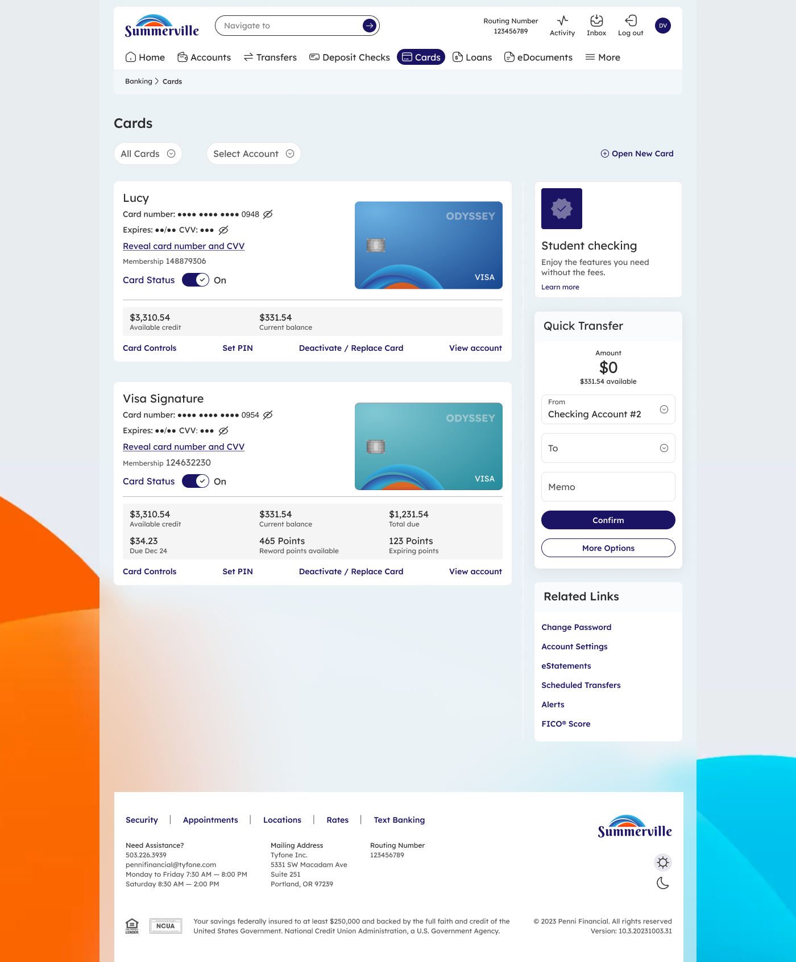

Step 2 Select "Request Replacement & Deactivate Card"
The Deactivate / Replace Card page asks what happened to your card. Enter a description if needed, then choose between two options: Deactivate Card (permanent, no replacement) or Request Replacement & Deactivate Card. Select Request Replacement & Deactivate Card to begin the digital reissuance. Click Continue.

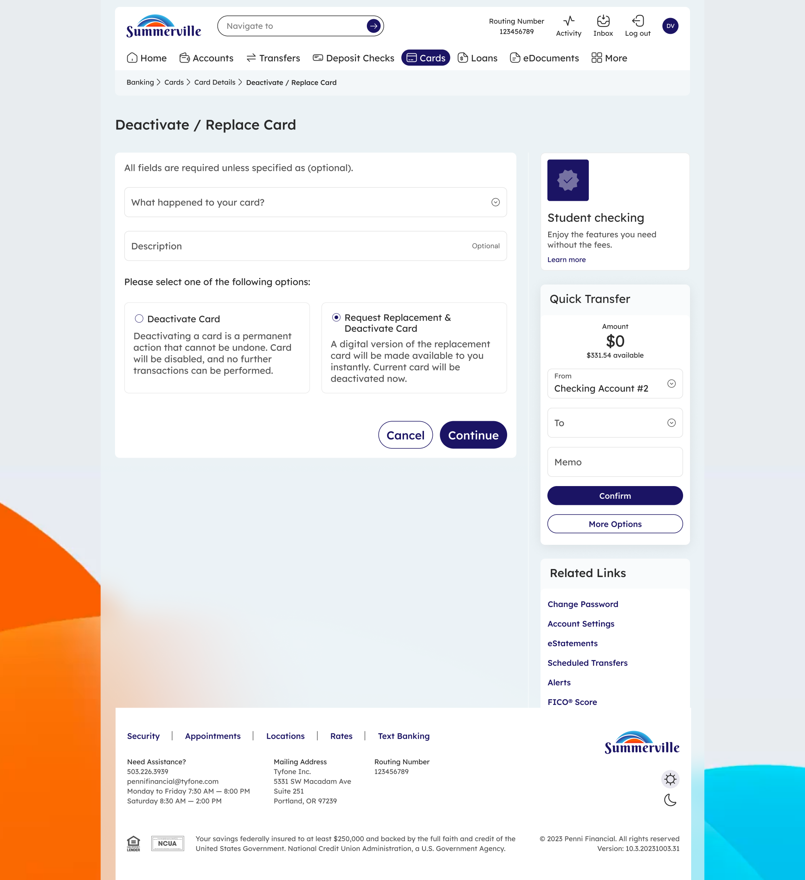

⚠️ Note: Selecting "Deactivate Card" permanently disables the card with no replacement. Always choose "Request Replacement & Deactivate Card" if you want a new card issued.

Step 3 Choose Digital-Only or Physical + Digital
On the Request Replacement form you will be asked: "Would you like a physical copy of your replacement card?" Choose your preferred option:

"Yes, Please" | A digital card is issued instantly AND a physical card is mailed to your address within 5 business days
"No, just digital" | A digital card is issued instantly only. You can request a physical card at any time after the digital card has been issued

Confirm or update your mailing address if selecting the physical card option. Then set a new 5-digit PIN for the replacement card and click Request Replacement and Deactivate Card to submit.

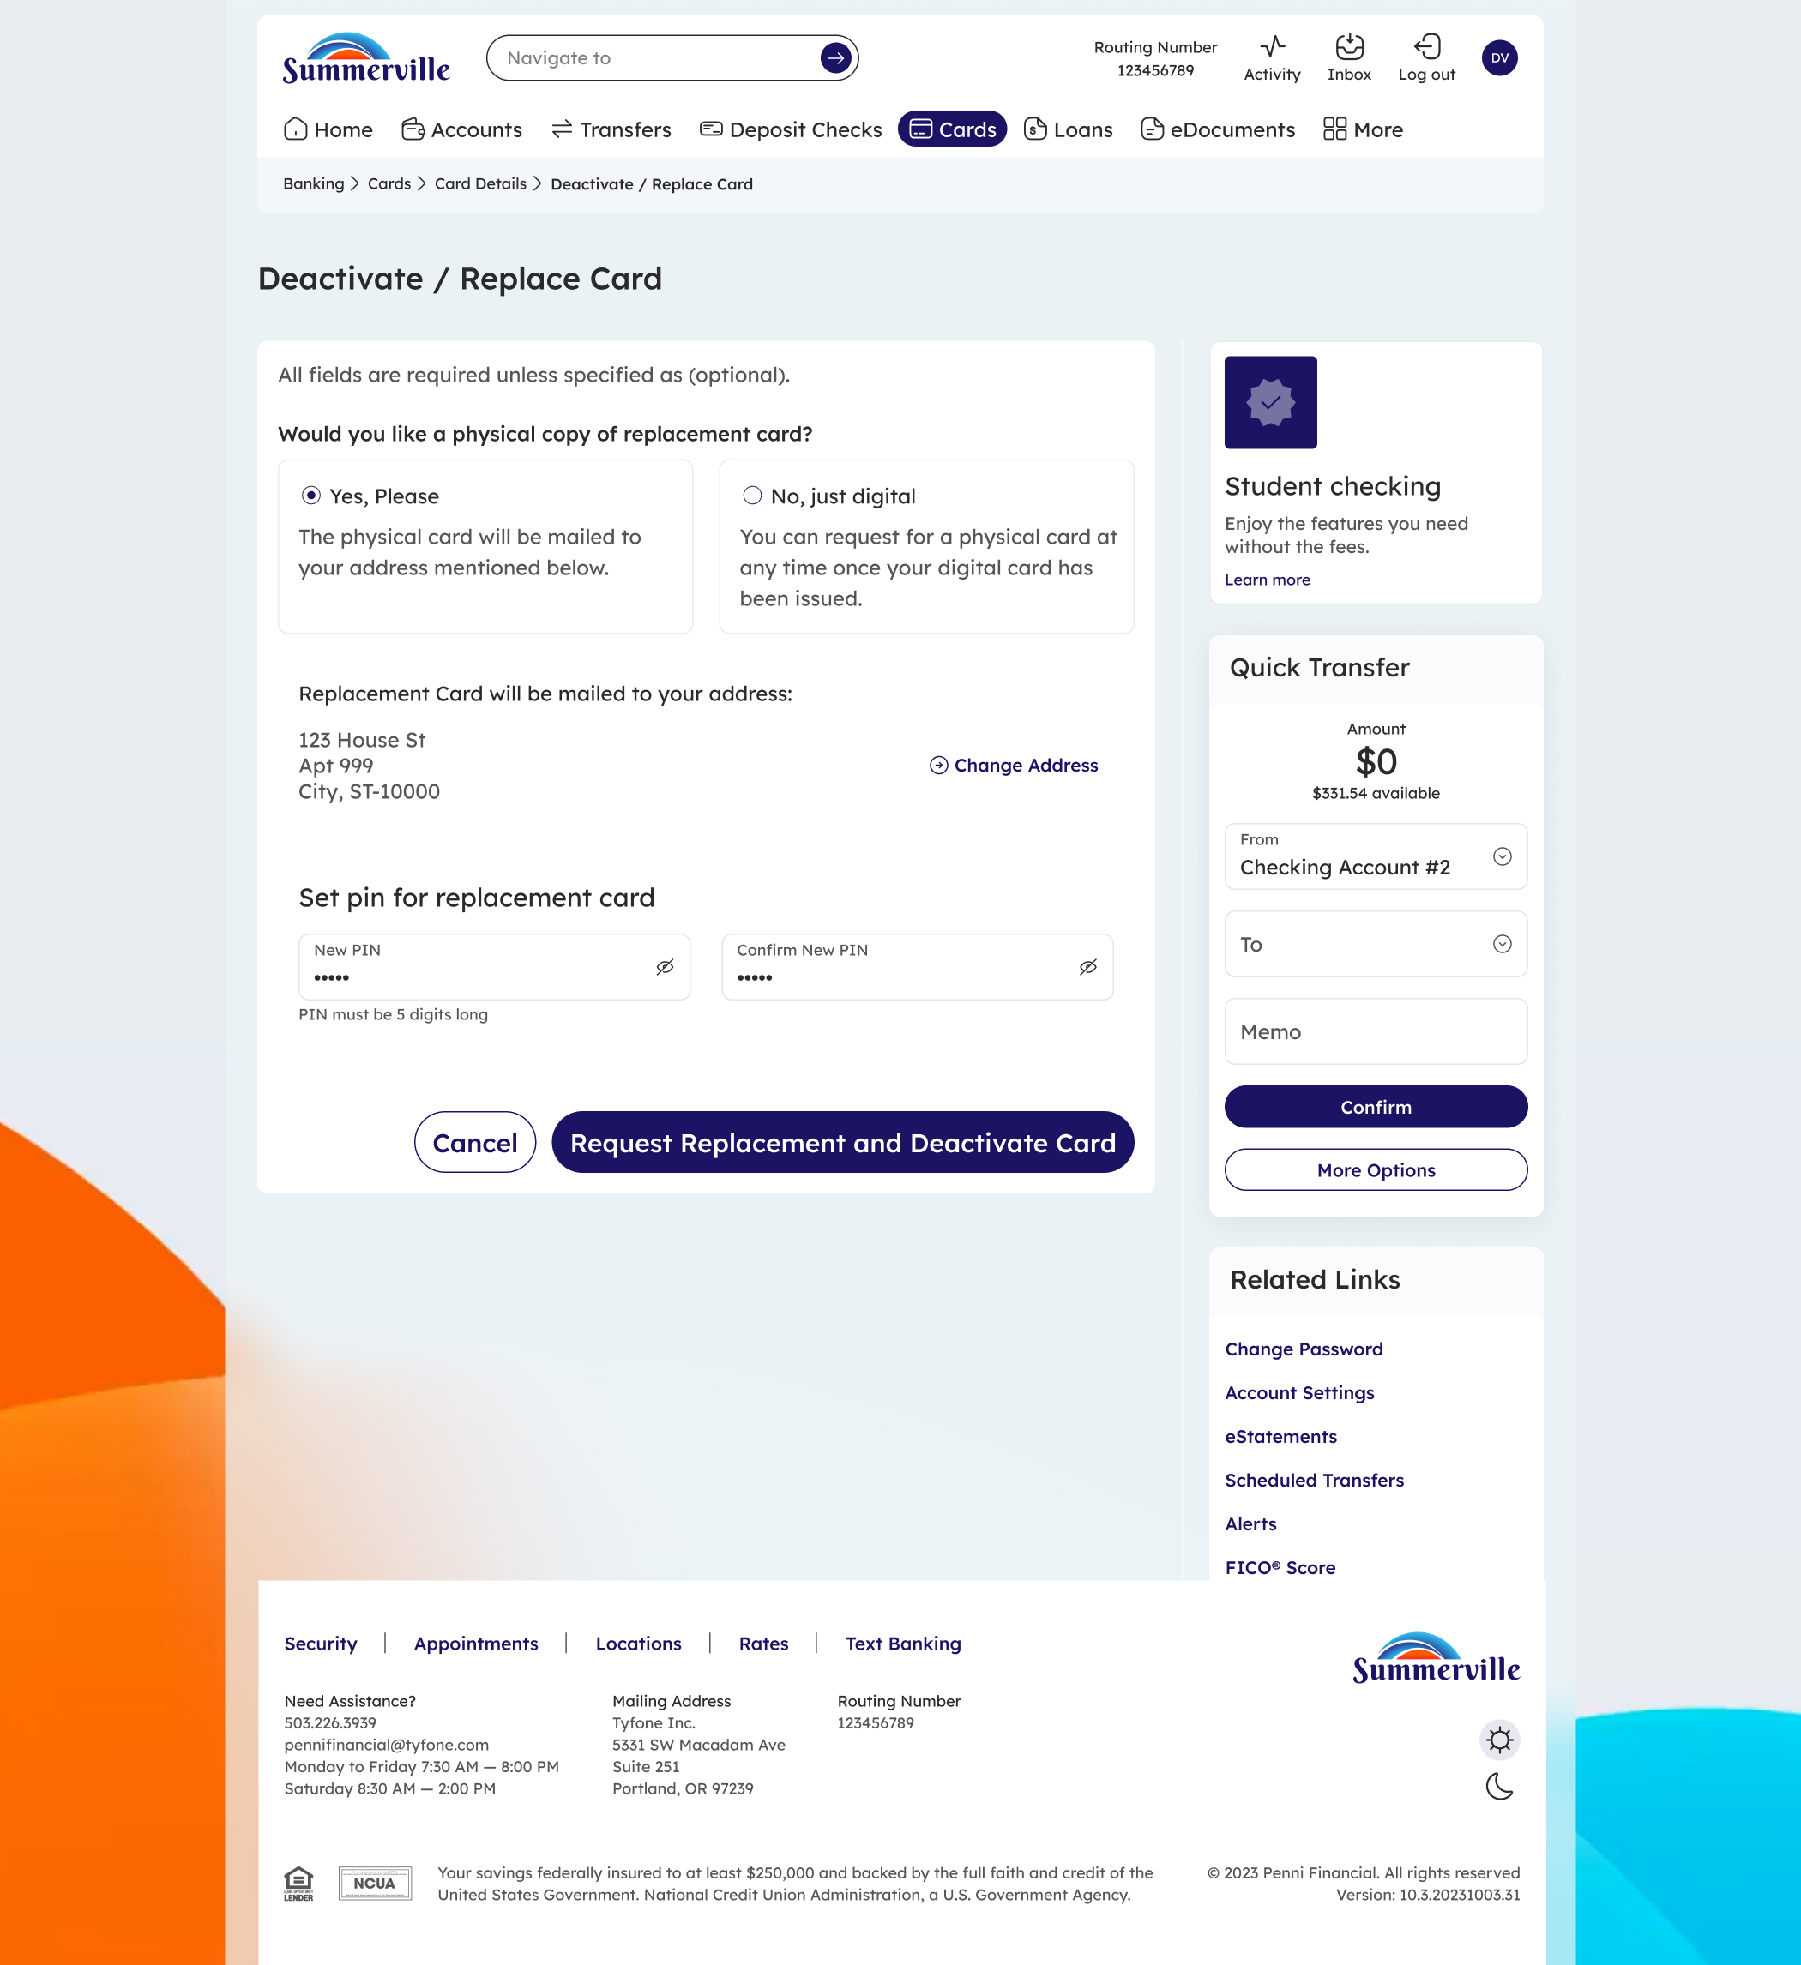

ℹ️ Tip: Your new PIN must be exactly 5 digits. Choose something memorable but different from your previous PIN for security.

Step 4 Replacement Confirmed — Digital Card Ready
Once submitted, a confirmation screen will confirm that the old card has been deactivated. Your new digital card is now available immediately in the Cards section. Navigate to Cards, find your new card tile, and click "Reveal card number and CVV" to see the new card number, expiry, and security code for online purchases.

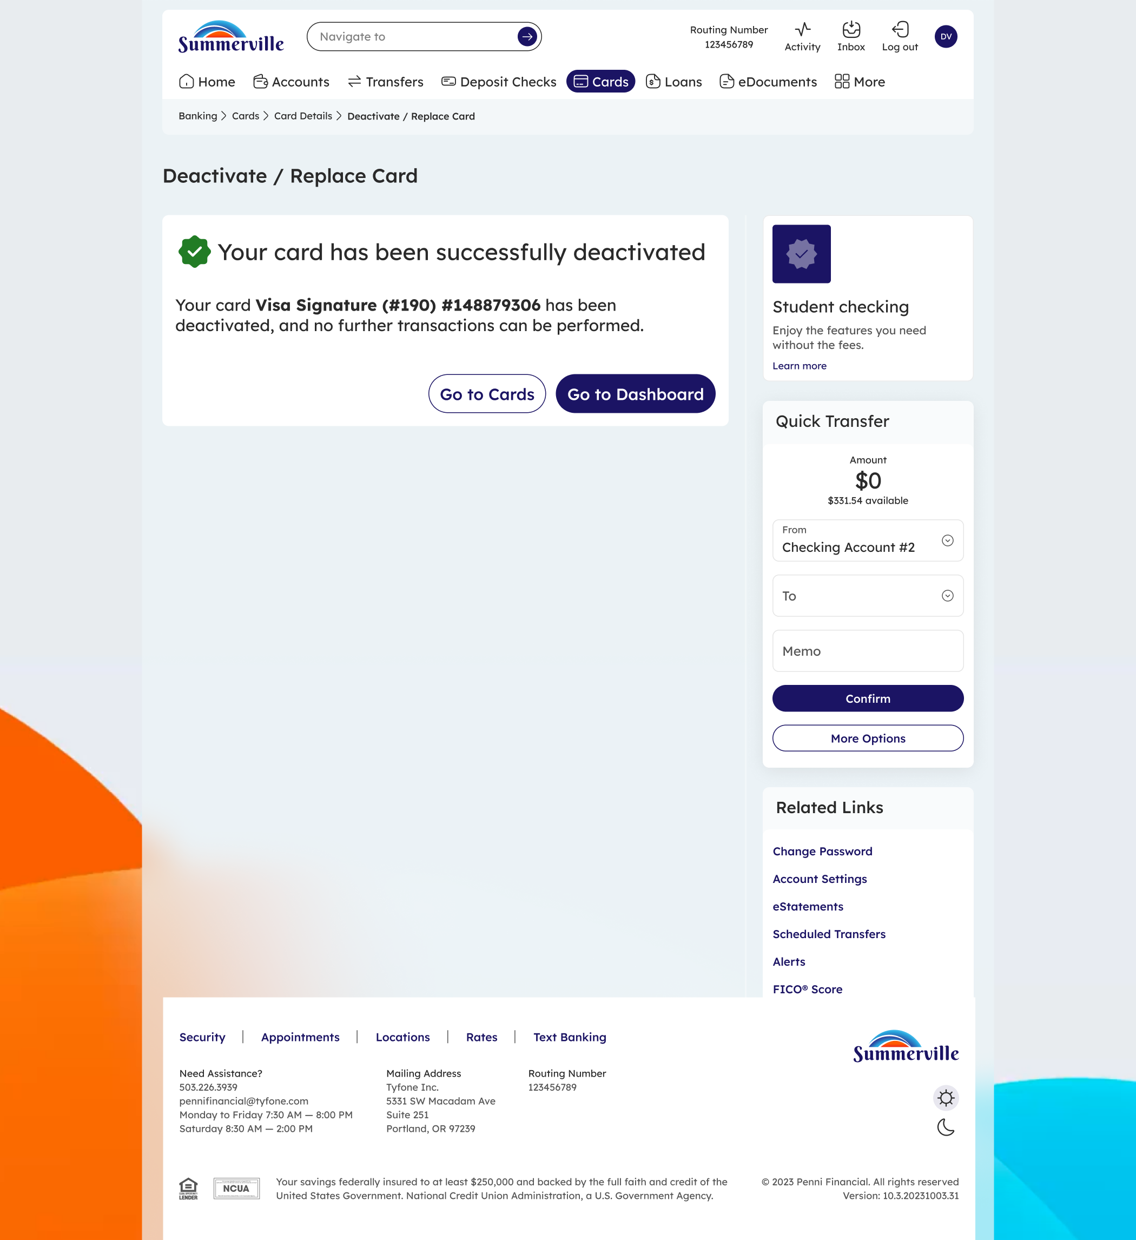

ℹ️ Tip: Your new digital card can be used for online purchases immediately. To use it for contactless payments, go to Card Details › Link Card and add it to your digital wallet.

